Mr.Accounting-GST V10 Upgrade | May 14  2018
This instruction will guide you to upgrade Mr. Accounting V10 from old version. Email: support@mysoft.com.my

Index:

1. Backup Mr. Accounting-GST
2. Install Mr. Accounting Patch
3. Install Java Offline
4. Update component file
5. Request new access code
6. Update database

How to upgrade Mr. Accounting Version 10
Step 1
Backup Mr. Accounting GST before upgrade
1) Click ‘Admin tool’
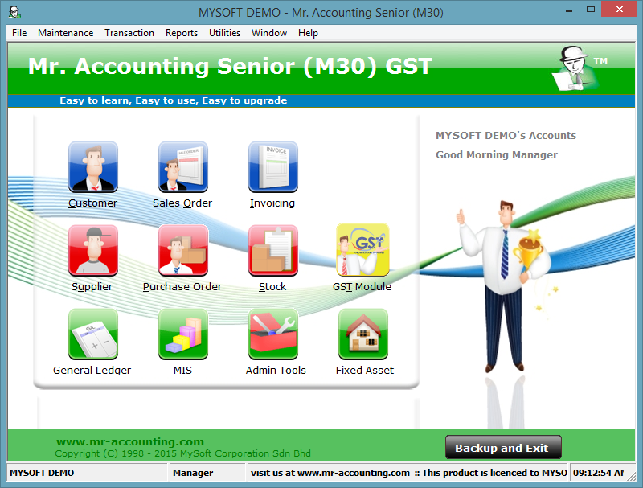
2) Click ‘Backup Data’
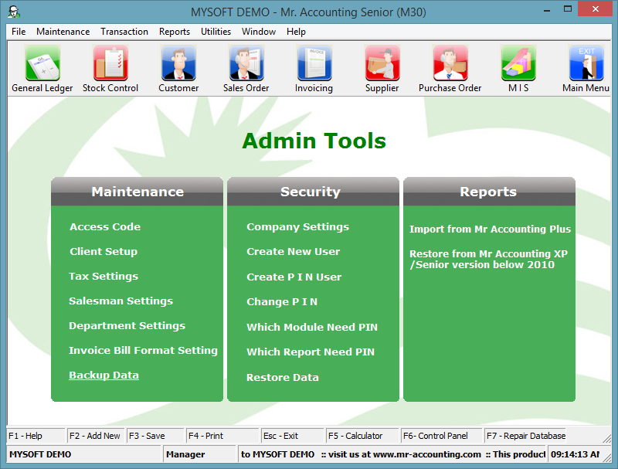
3) i) select the location u want to backup
ii) Tick the box ‘Please tick to backup Report’
iii) Click ‘Backup’
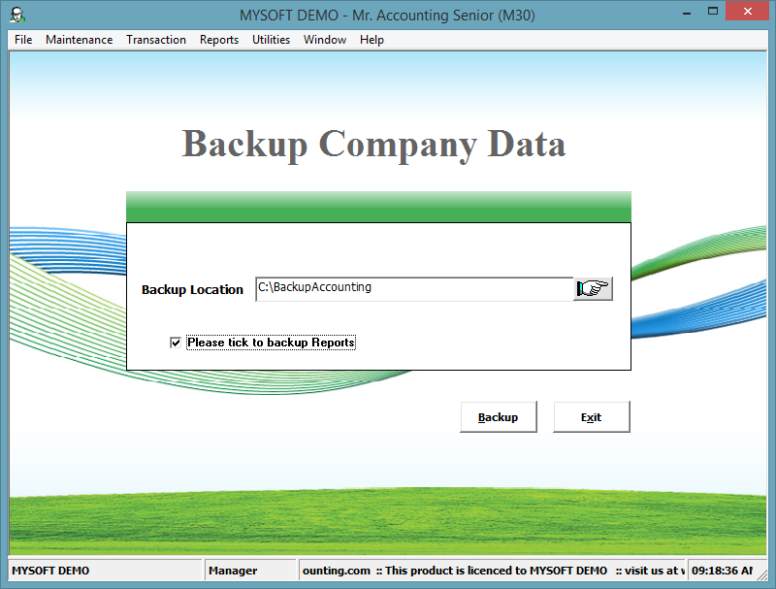
iii

ii

i

4) Click ‘Yes’
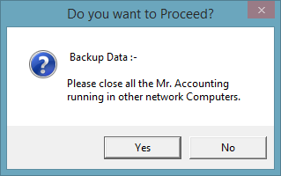
5) Click ‘Ok’
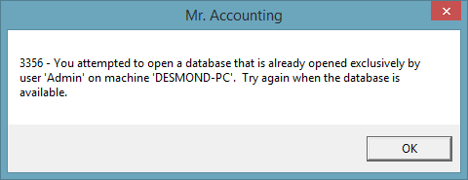
6) Wait until the processing bar finish running.
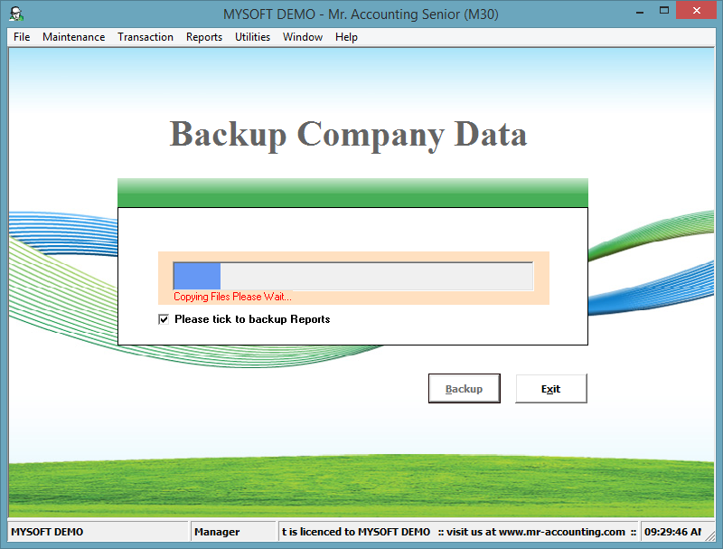
7) Click ‘Ok’
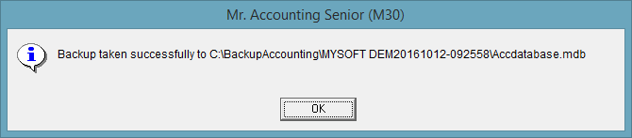
Step 2
1) Double click the file ‘MrAccounting-GST Patch’ in the Mr. Accounting upgrade folder.
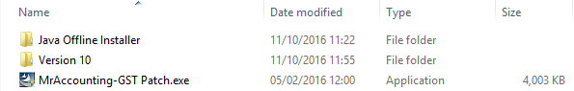
2) Click ‘next’.
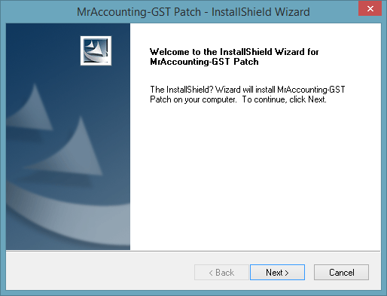
3) Select the ‘accept the terms of t he license agreement’ and click ‘next’.
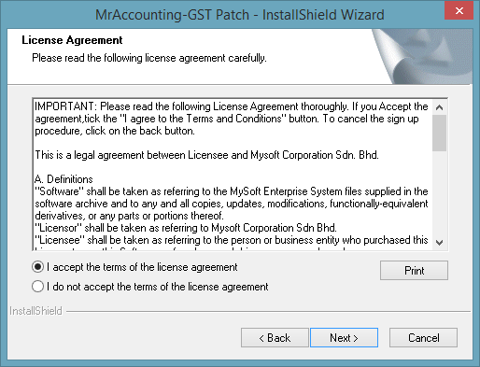

4) Click ‘Install’
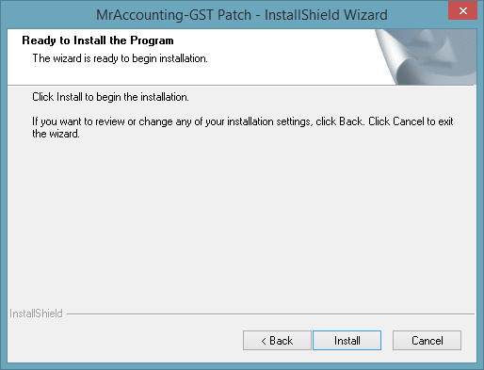
5) Wait until the processing bar finish running.
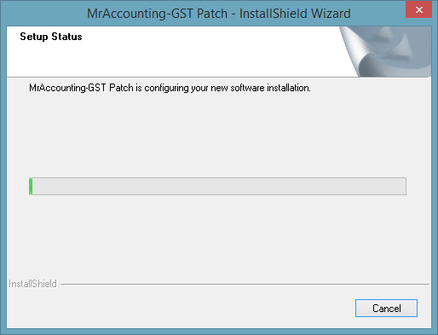
6) Click ‘Finish’
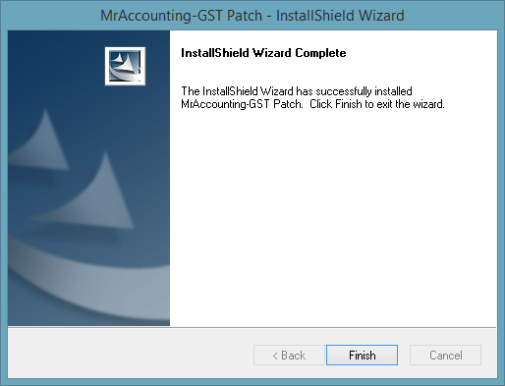
Step 3
1) Open the ‘Java Offline Installer’ folder.
2) Install the ‘jre-8u102-windows’ base on computer bit.
32-bit computer please select ‘jre-8u102-windows-32-bit’
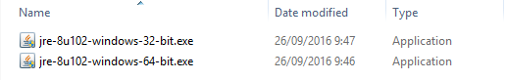

64-bit computer please select ‘jre-8u102-windows-64-bit’

•How to check computer bit.
-Windows XP normally is 32-bit
-Windows 7/8/10 please follow the step below
i) Open ‘This PC’/ ‘My Computer’
ii) Right click in the free place in the folder and click the ‘Properties’
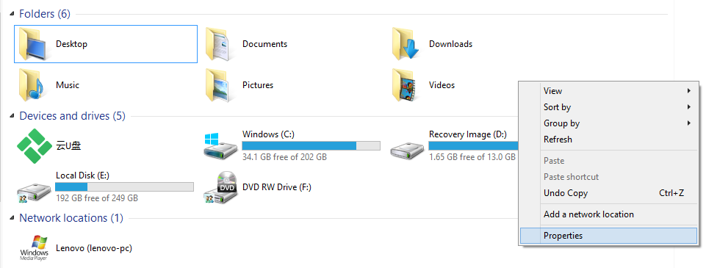

Computer bit will be show as at below.
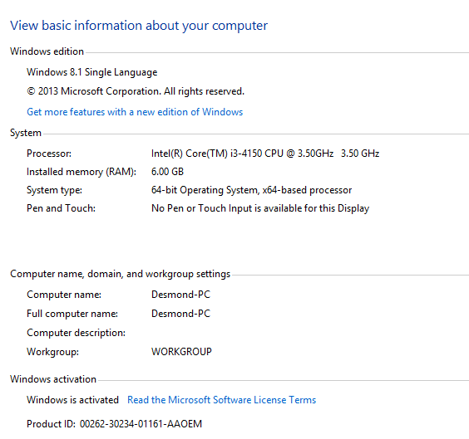
3) Click ‘Install >’
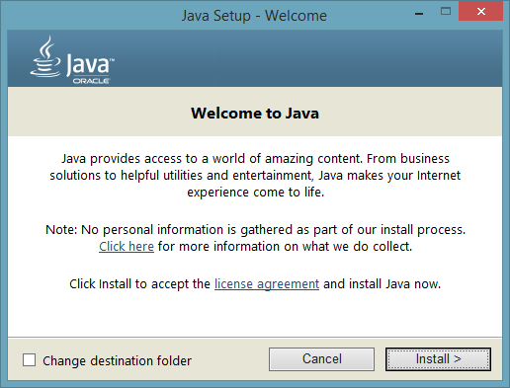
4) Wait until the processing bar finish running.
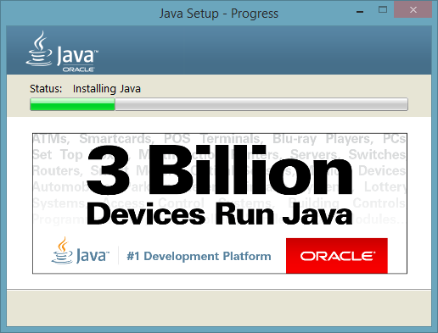
5) Click ‘Close’
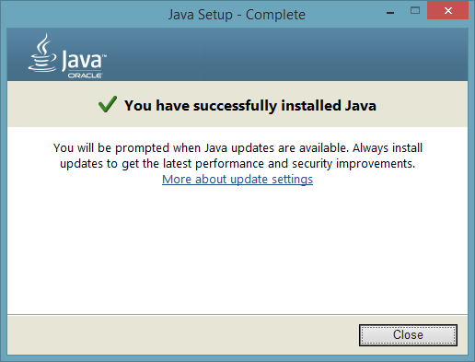
Step 4
1) Open the ‘Version 10’ folder.
2) Open the ‘Mr.Accounting GST’ folder.
3) Copy all the File and Folder.
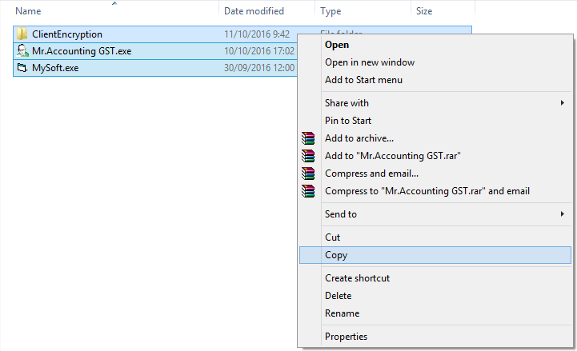

4) Open Mr.Accounting GST Folder
Windows 7/8/10
Right click Mr.Accounting-GST in Desktop and click ‘Open file location’
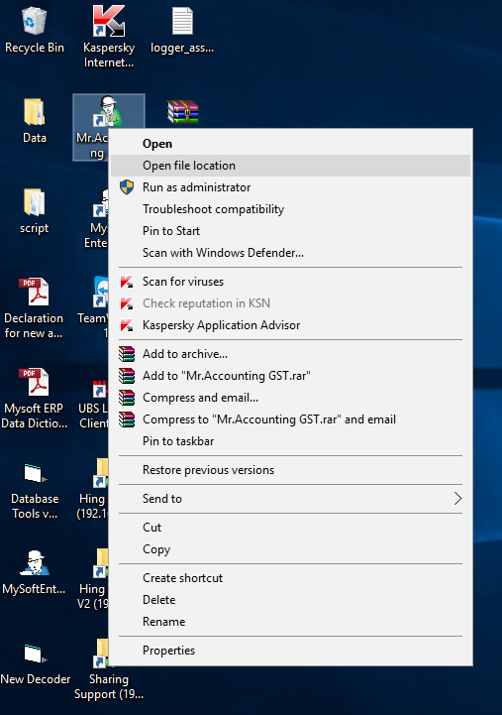
Windows XP
Right click Mr.Accounting-GST in Desktop and click ‘Properties’
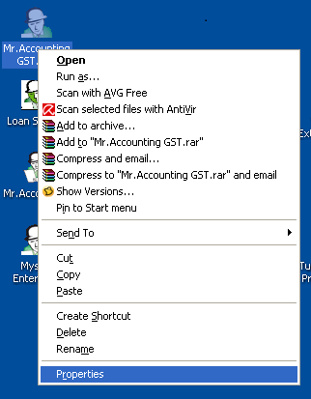
Click ‘Find Target…’
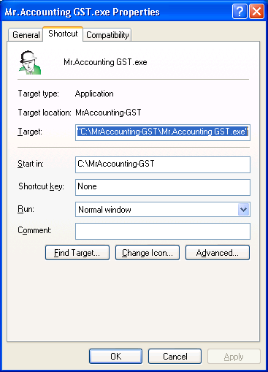
5) Paste all the File and Folder in Mr.Accounting GST Folder
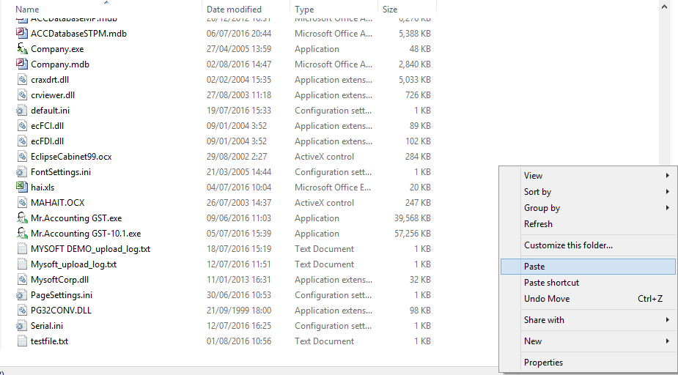
6) Click ‘Replace the file in the destination’
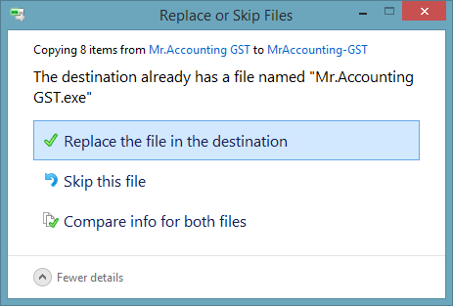

Step 5
1) Open Mr.Accounting GST, and login the company.
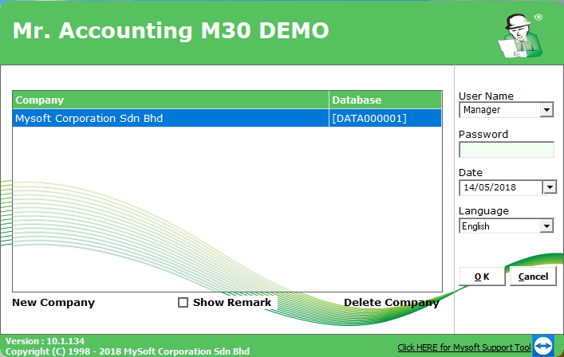
2) Go to Admin Tools > Access Code > Batch Registration Form
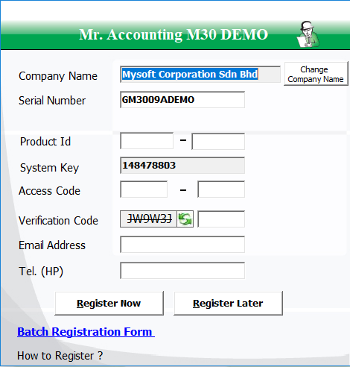
3) Tick the company you want to register, click Print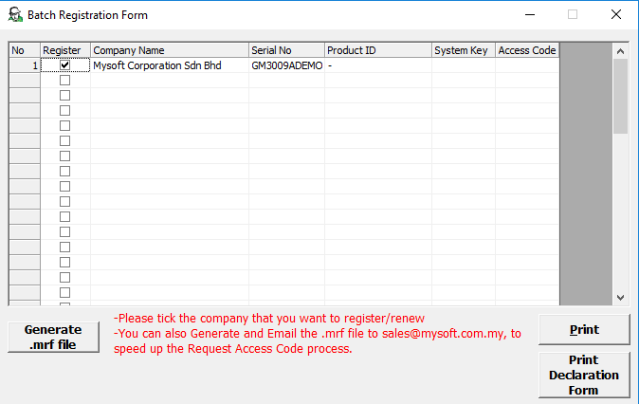

4) Click ”Export Report” icon on the top second left, and export it as .pdf format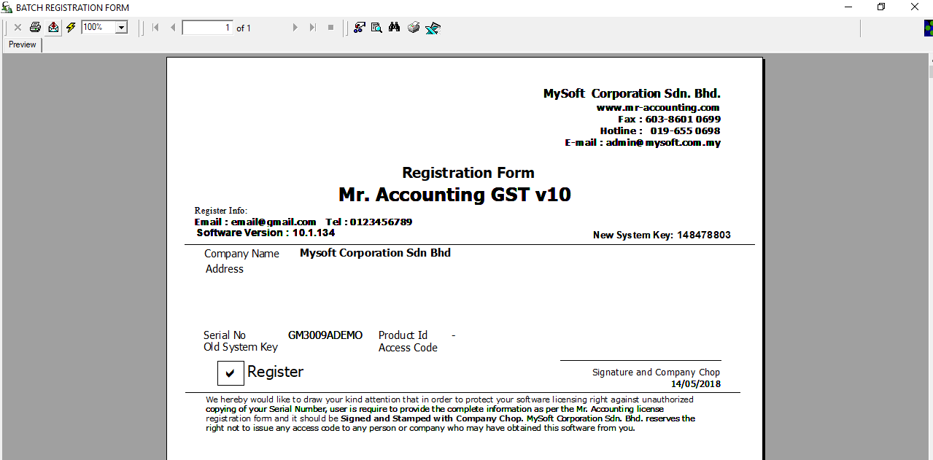
5) Print this registration form and send it to support@mysoft.com.my to process your new access code.
6) Once you received your new access code, please fill in your new access code and verification code, and click “Register Now”
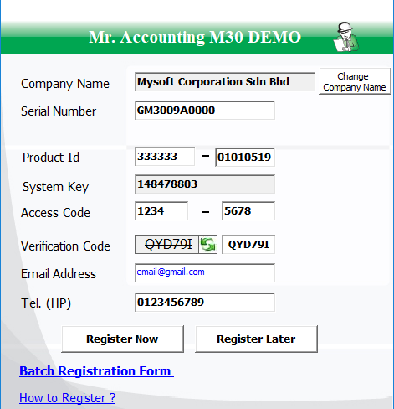

Step 6
1) Go back to main menu of Mr.Accounting GST
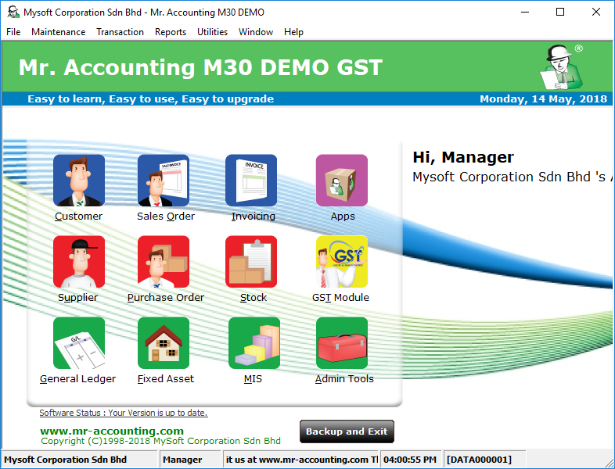

2) Click “File” on the top left, click “D. Update Database” and click Yes
